Angular arch::

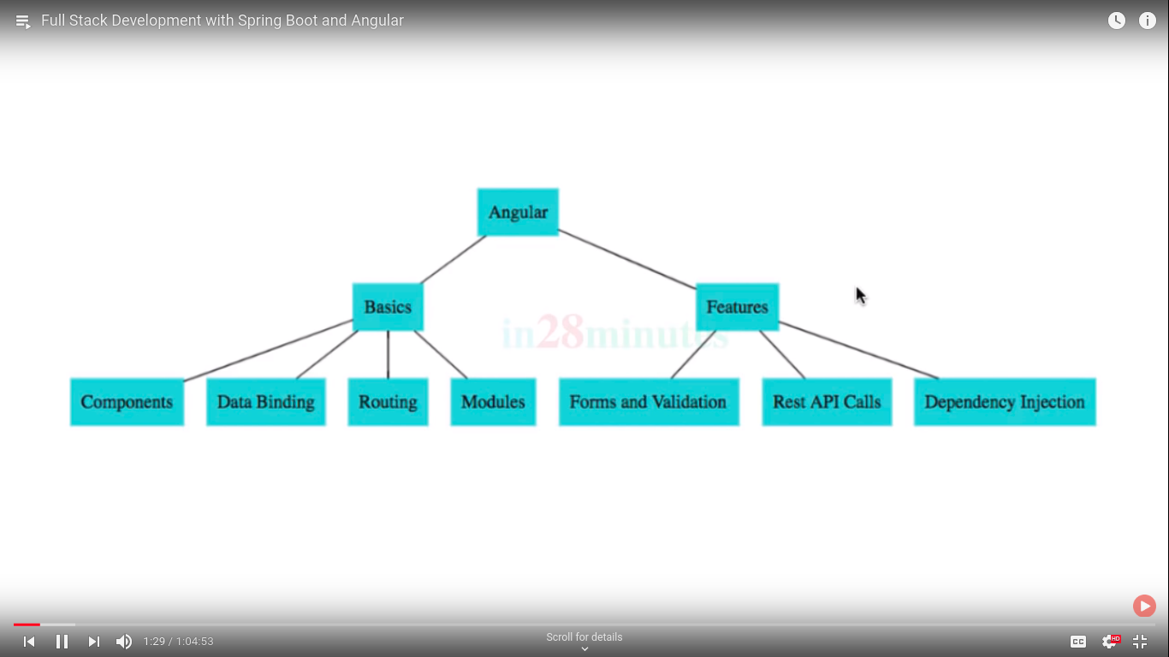

Spring security and jwt also used for configures:;

high level arch..

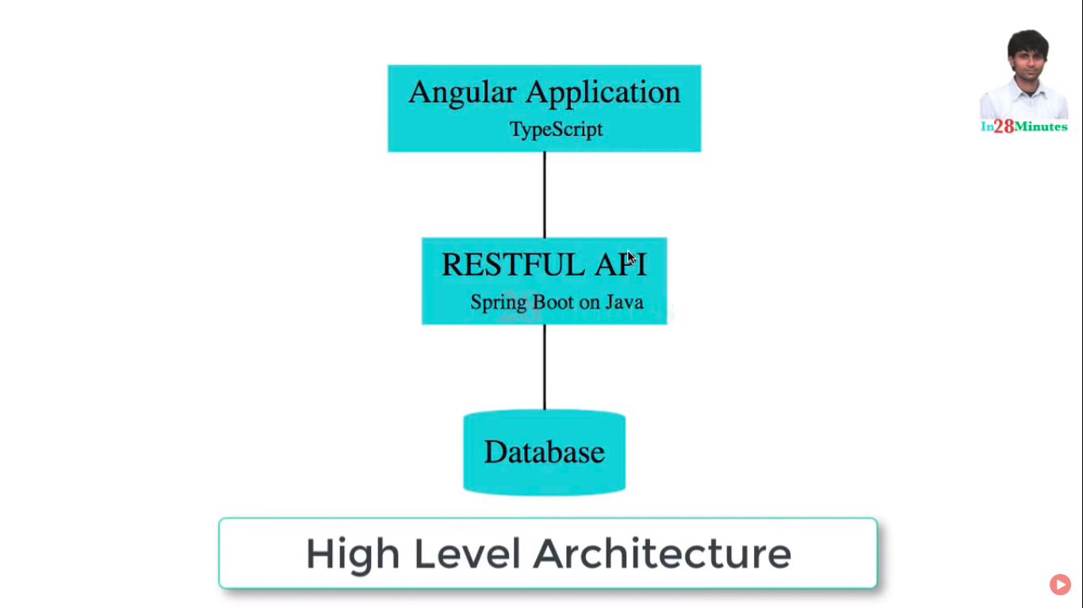

Angular usages typescript.

Basic authentication and jwt with spring security..

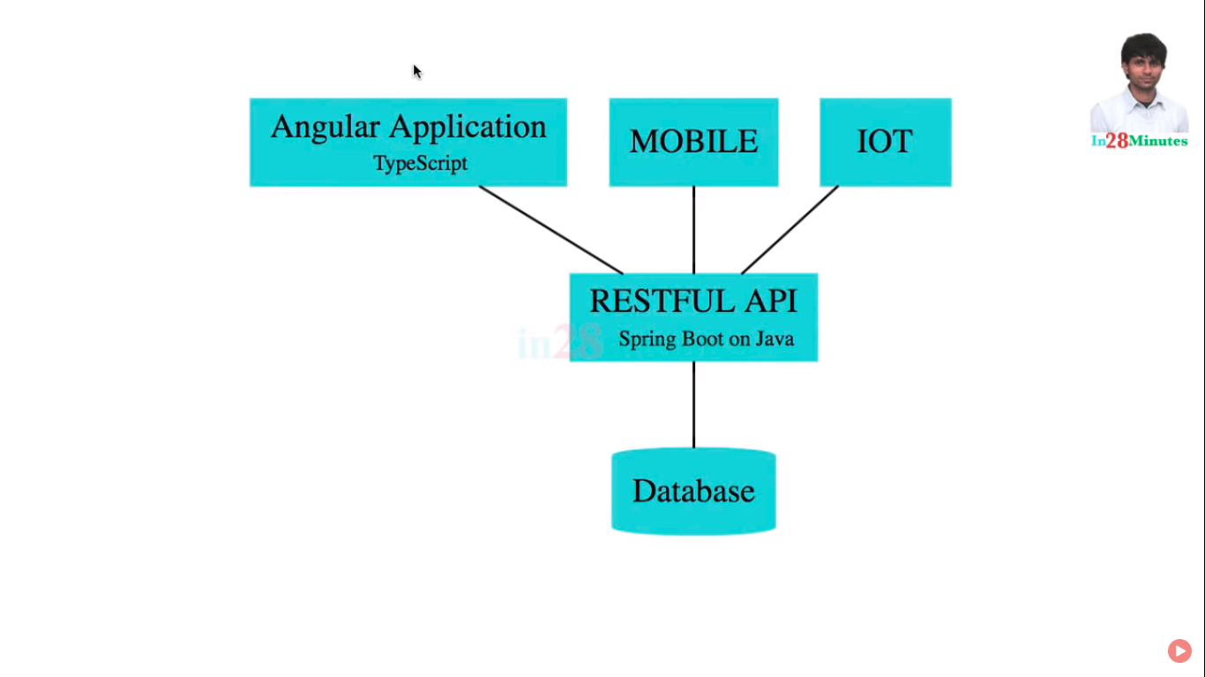

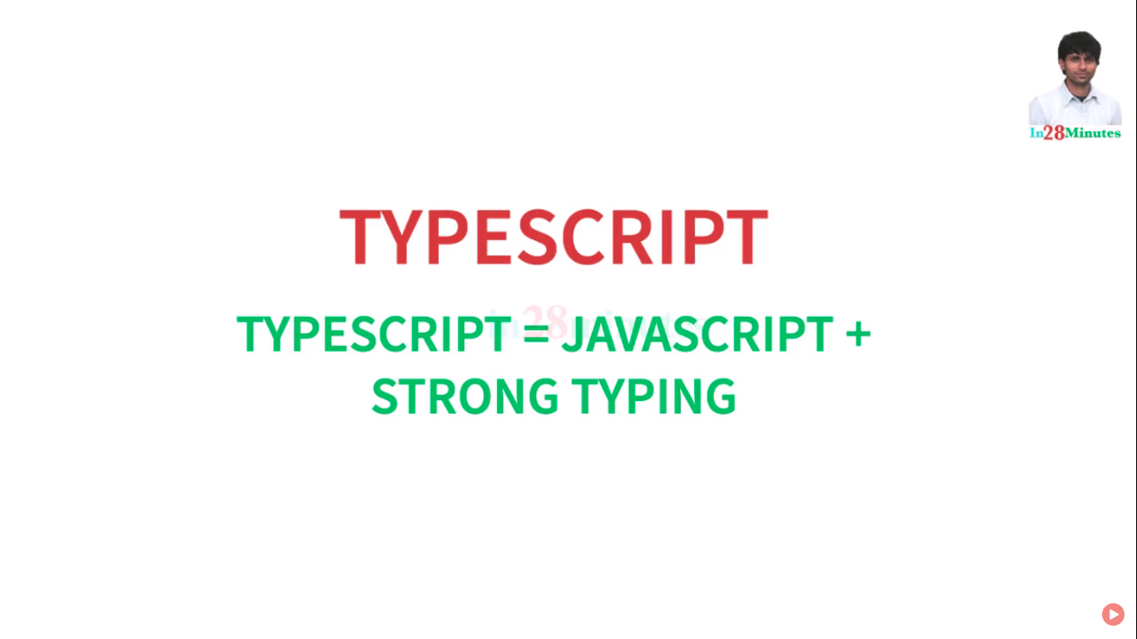

moder java script::

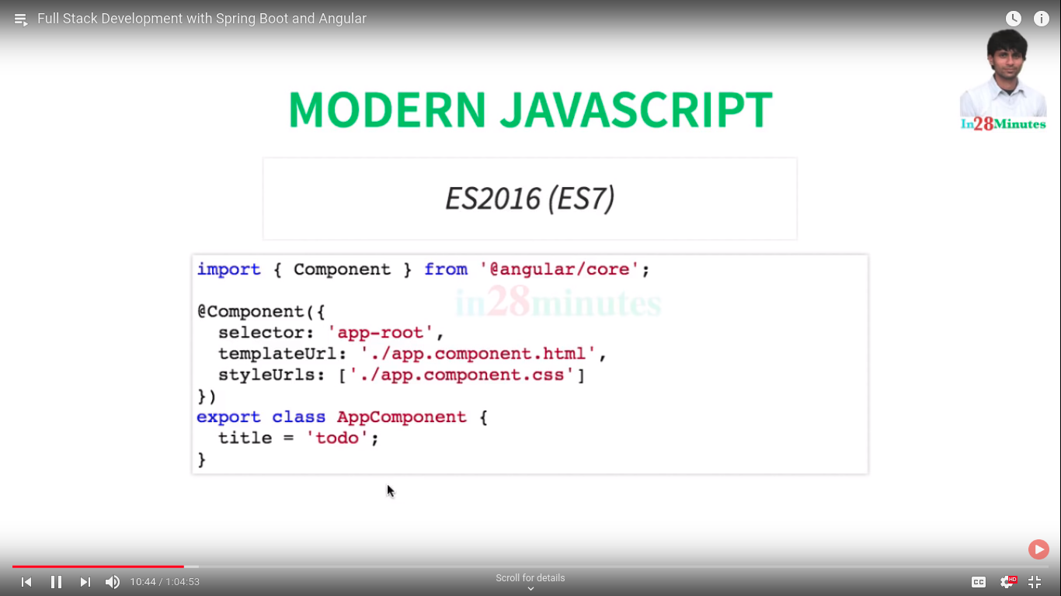

java script evaluation::



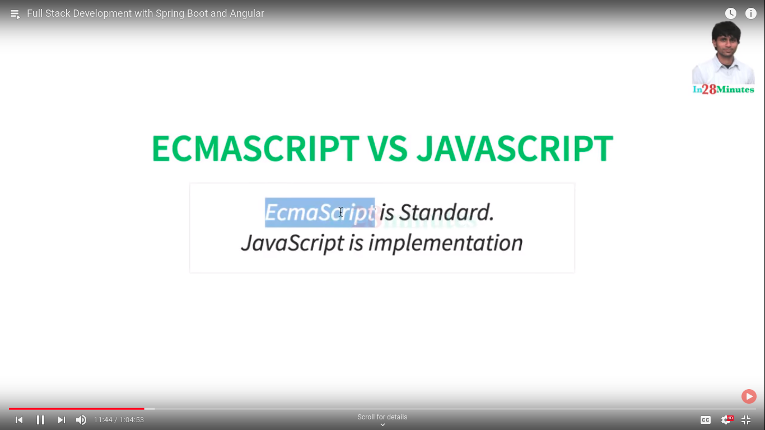

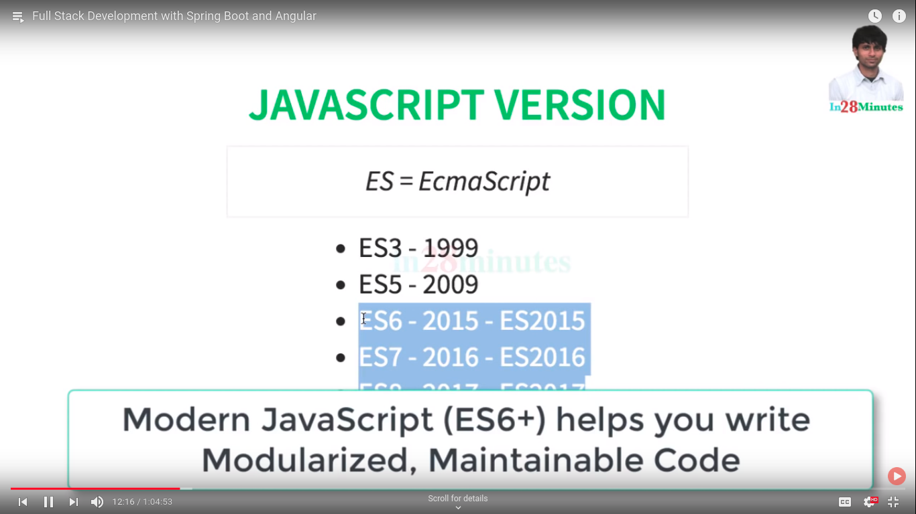

var value;

value=4;

value=”string”;

in type script

value:number

value=9;

value=”name” //compilation error

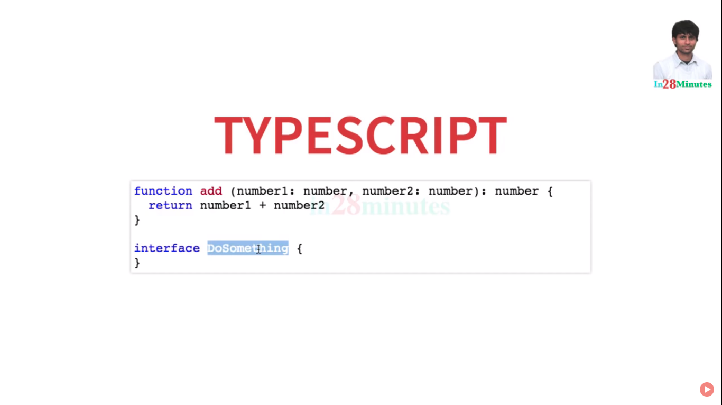

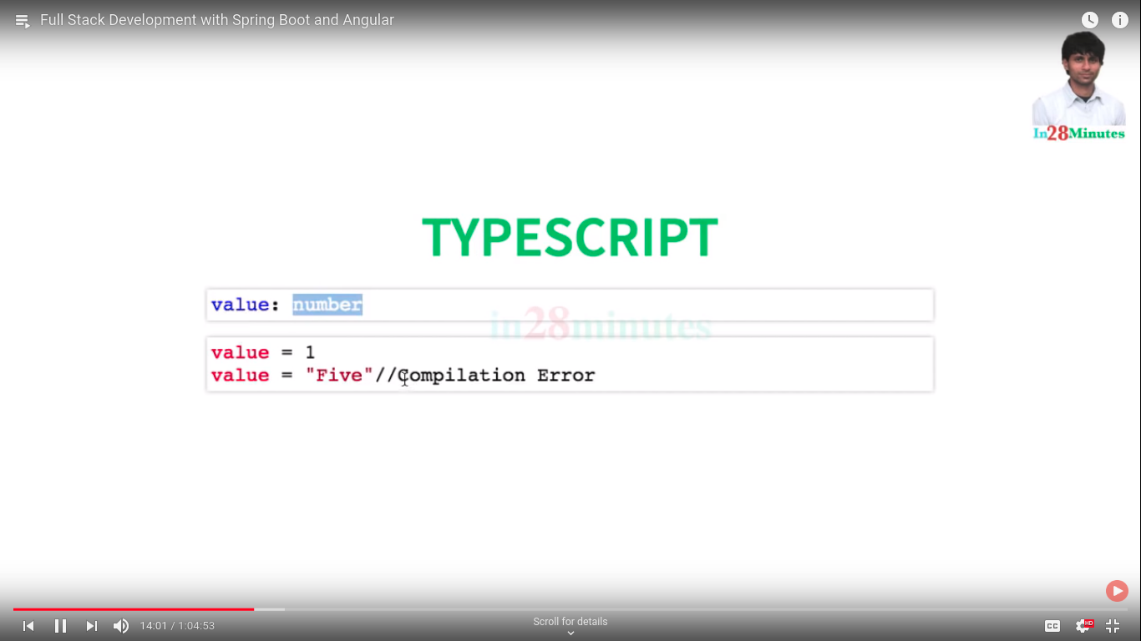

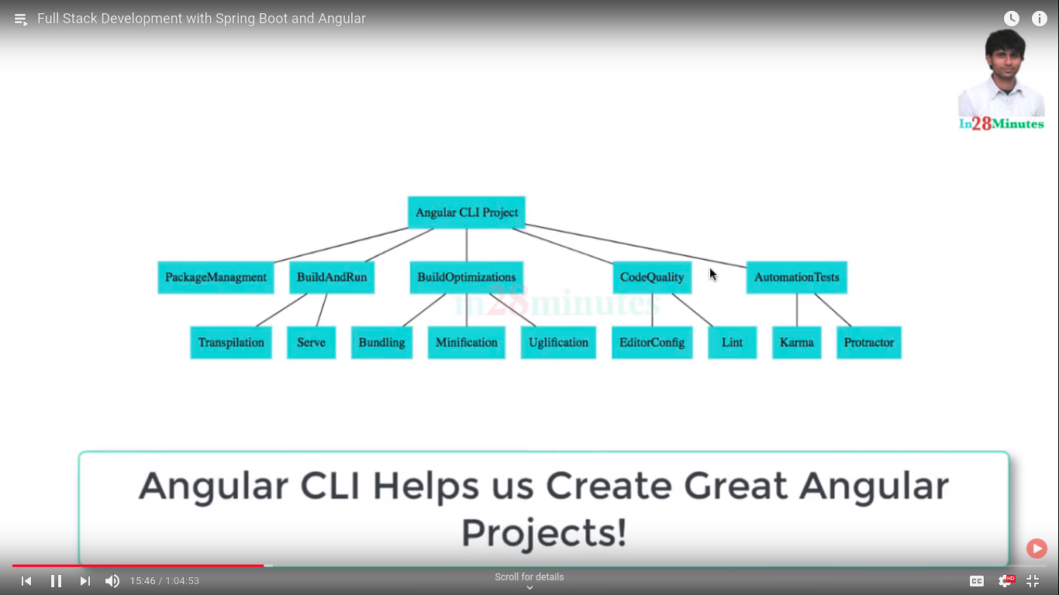

angular cli installations::

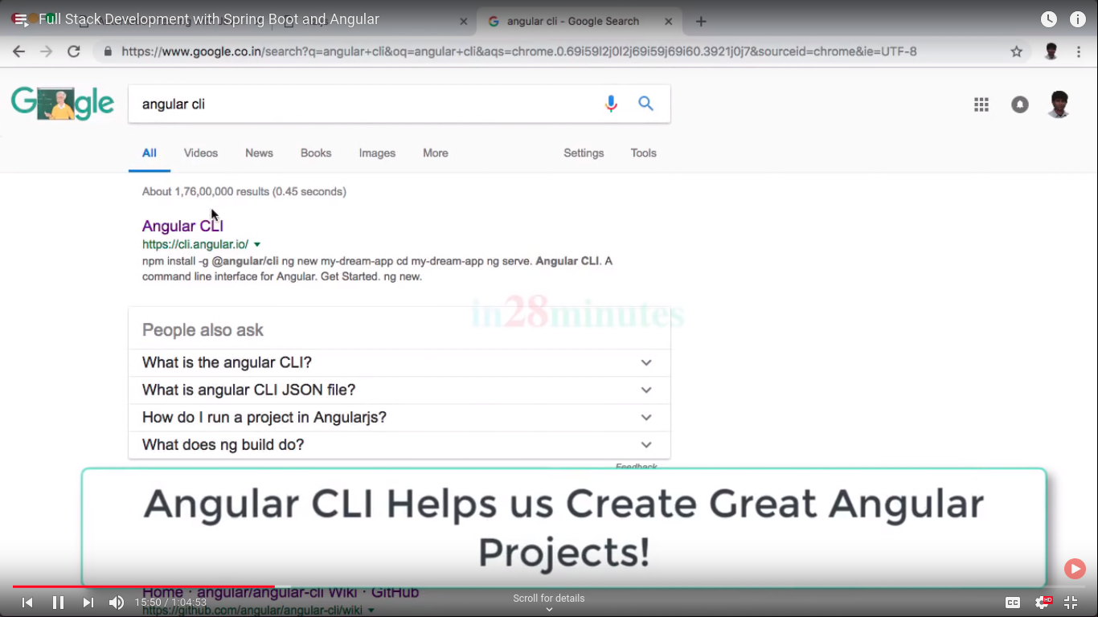

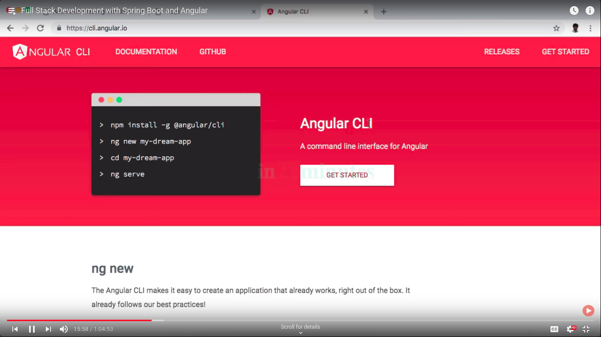

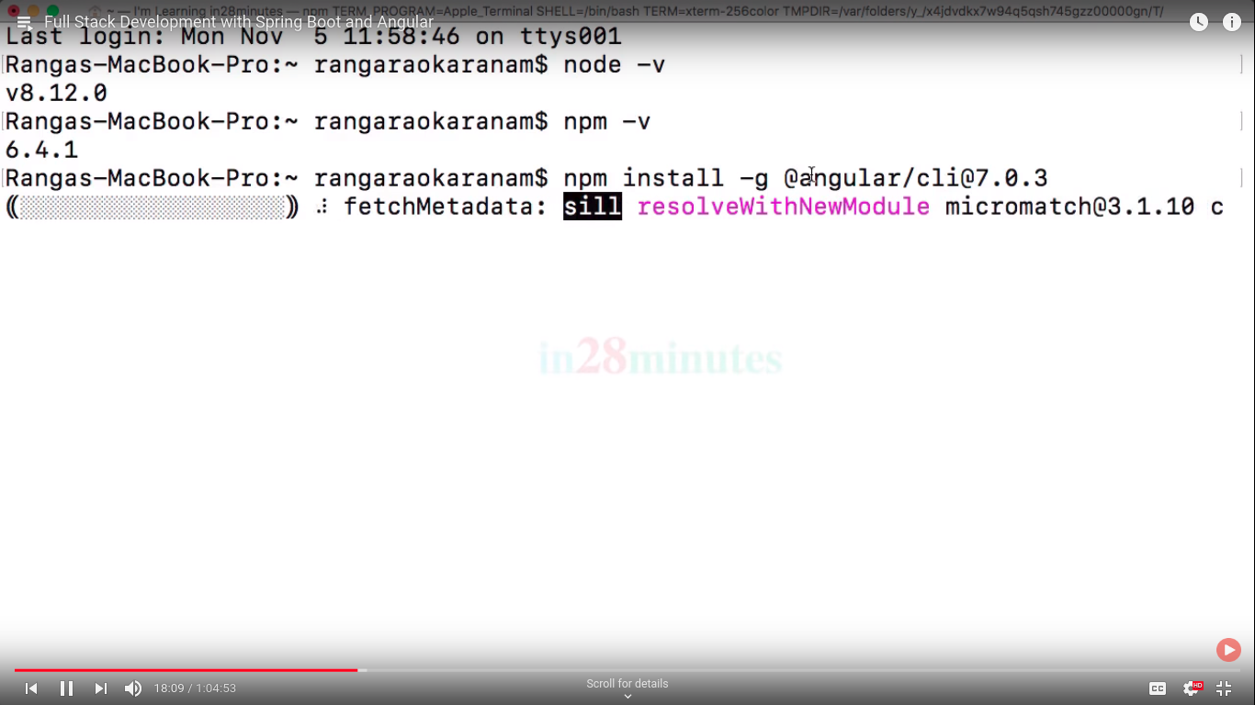npm is like maven ::

needs admin privalges for storing angluar

angluar cli version ::

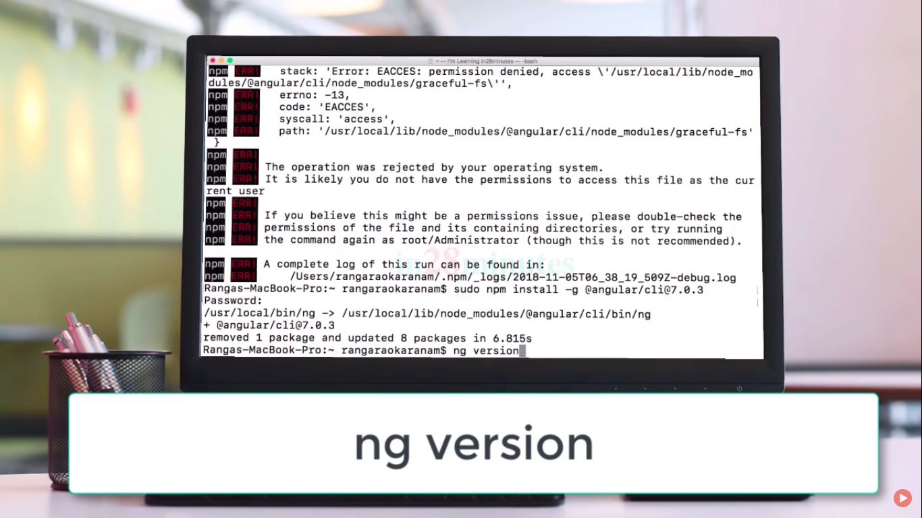

ng help::

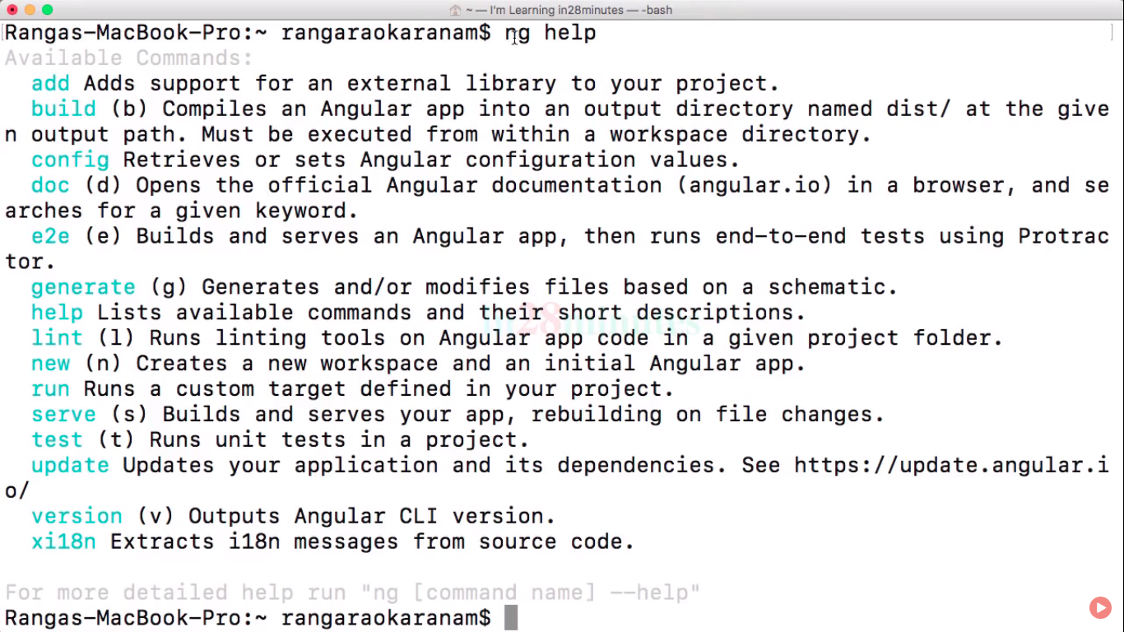

when we used angluar it useage module ,component ,services .. they are genrated using genrate command..

ng server ==>code changes picked up runtime

ng build ==> for building apps..

angular :: app creation ====

angluar routing ==> is used for multiple screens

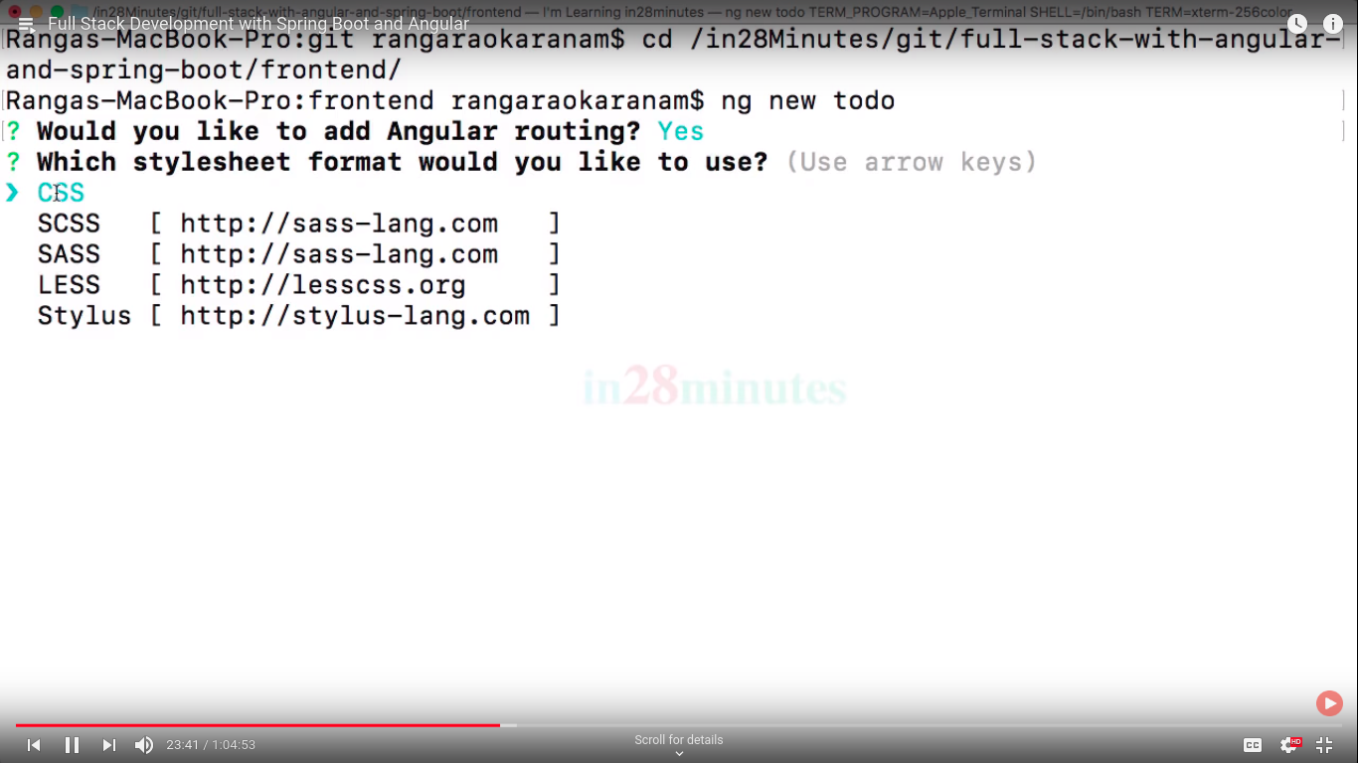

for build and run the application using ::

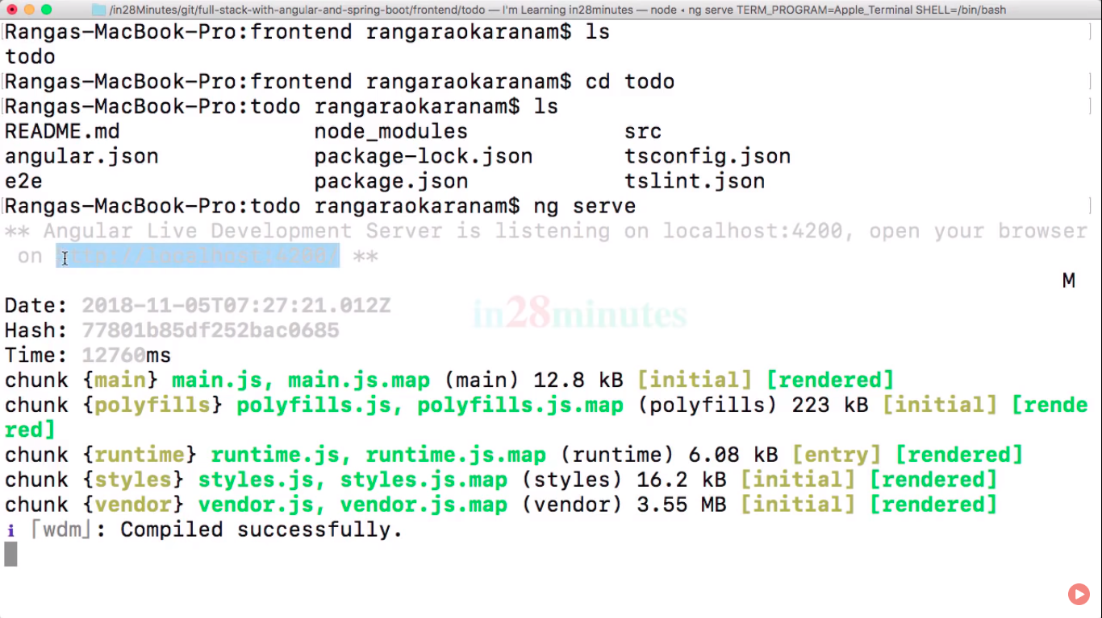

first application::

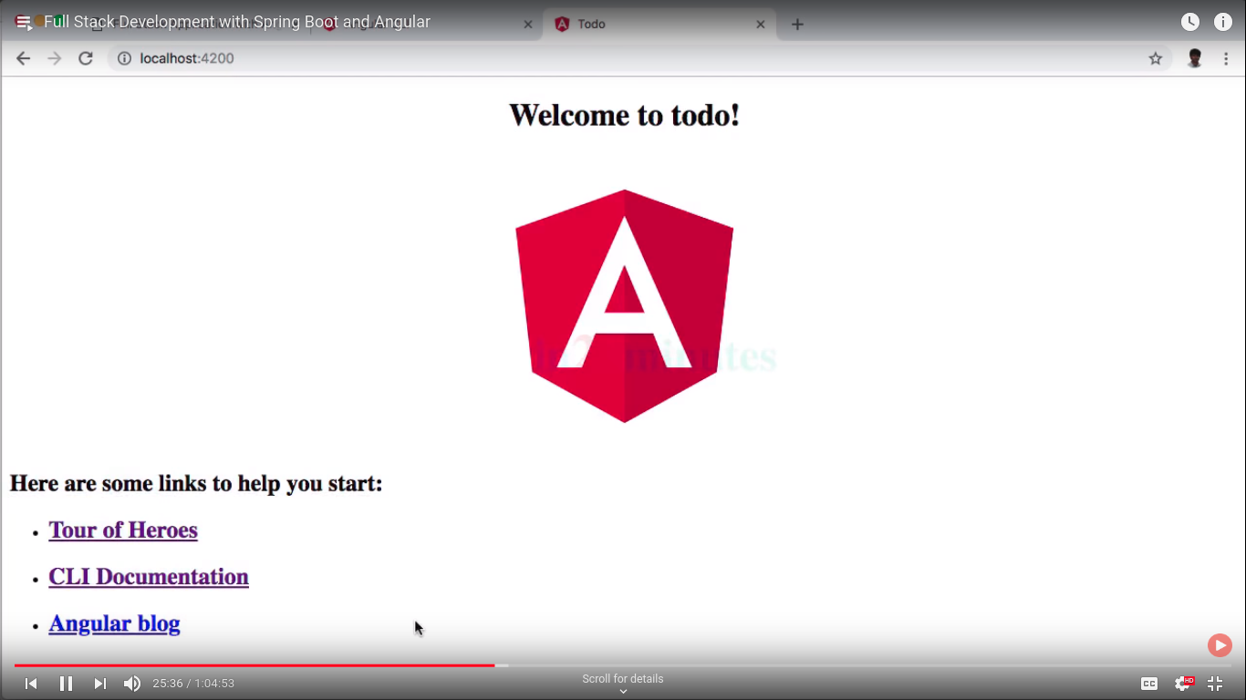

now going to source directory and explorer more about angular::

start from index.html which is basically main file on this structure ..

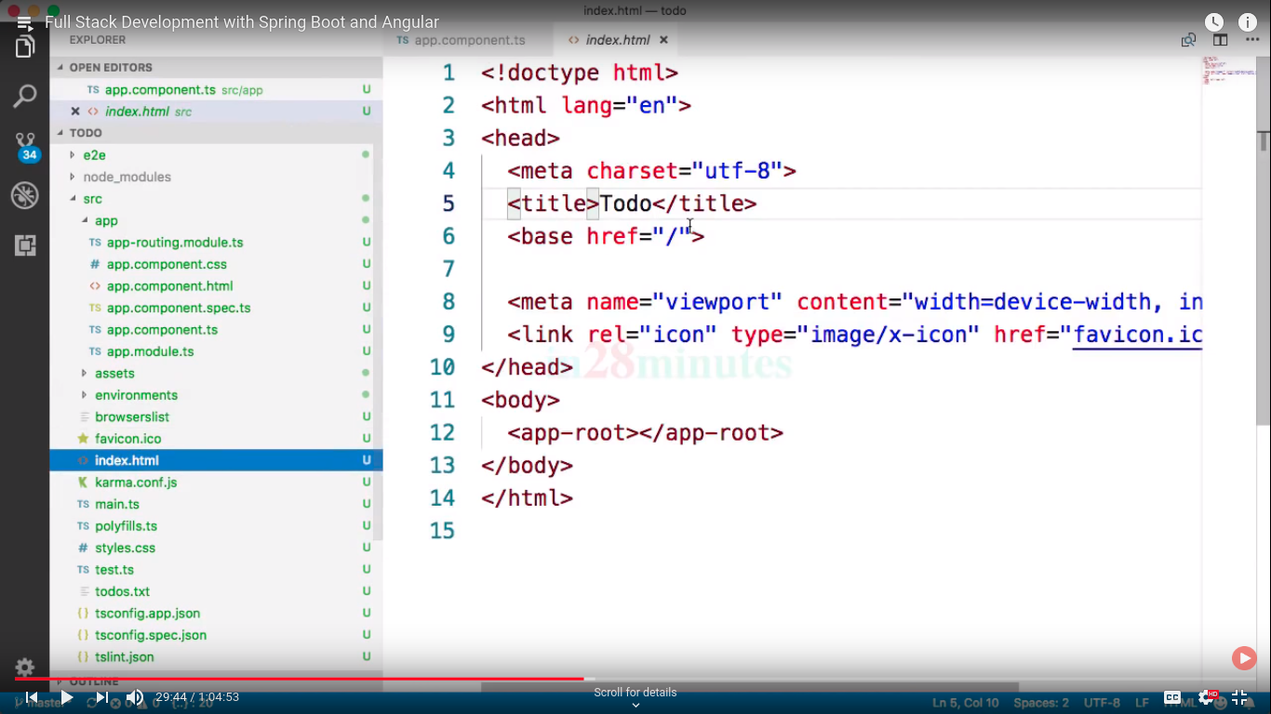

now going bit more on app folder where app.componet.html file contain all information about first page..

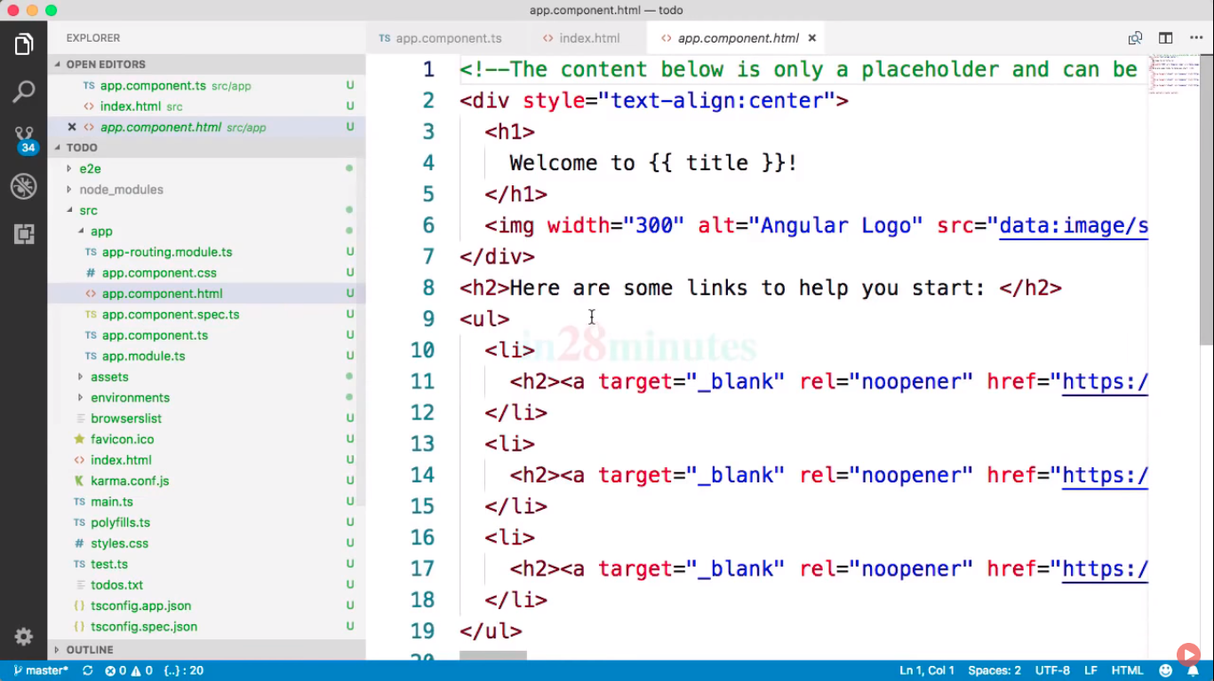

ng lint command for checking violaiton in project..

LINT:: Checking your code for standard ..

EVERY TS file must be end with new line..

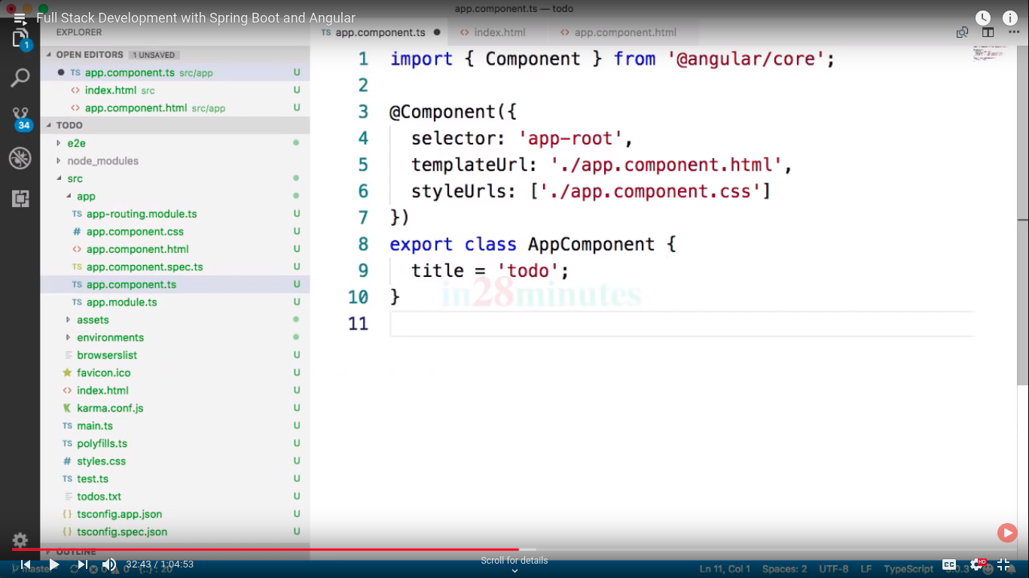

now If we remove new line at end it showing error while linting command..

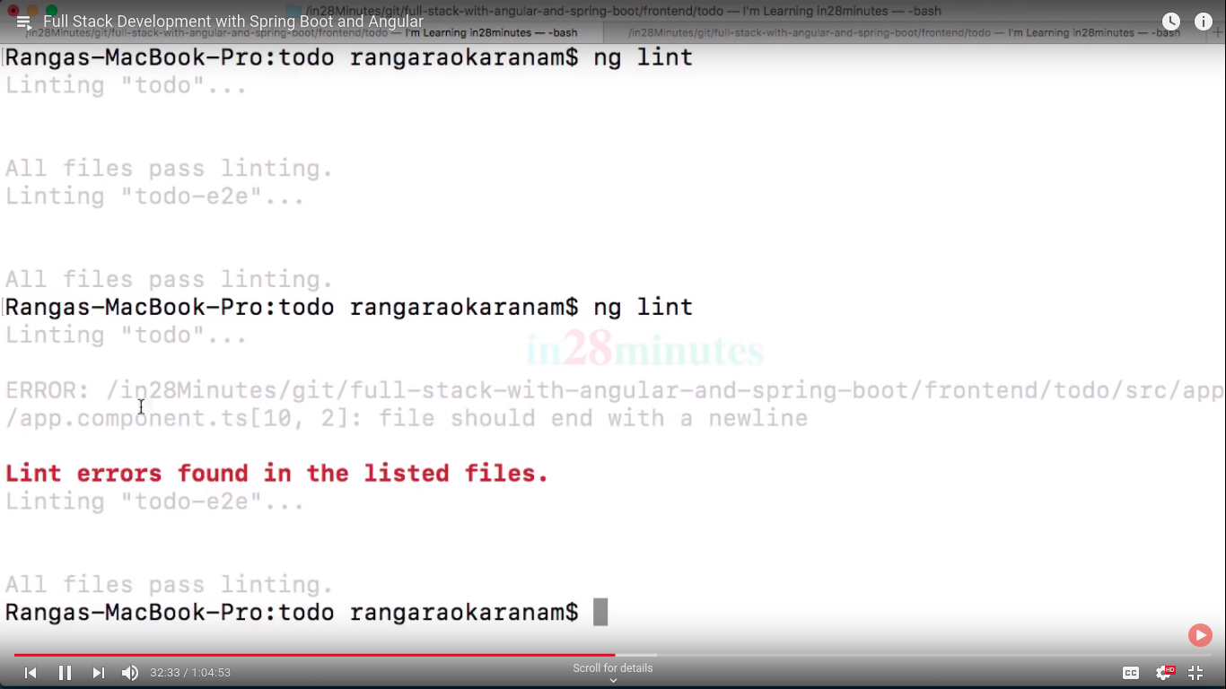

all rules are define in tslint.json

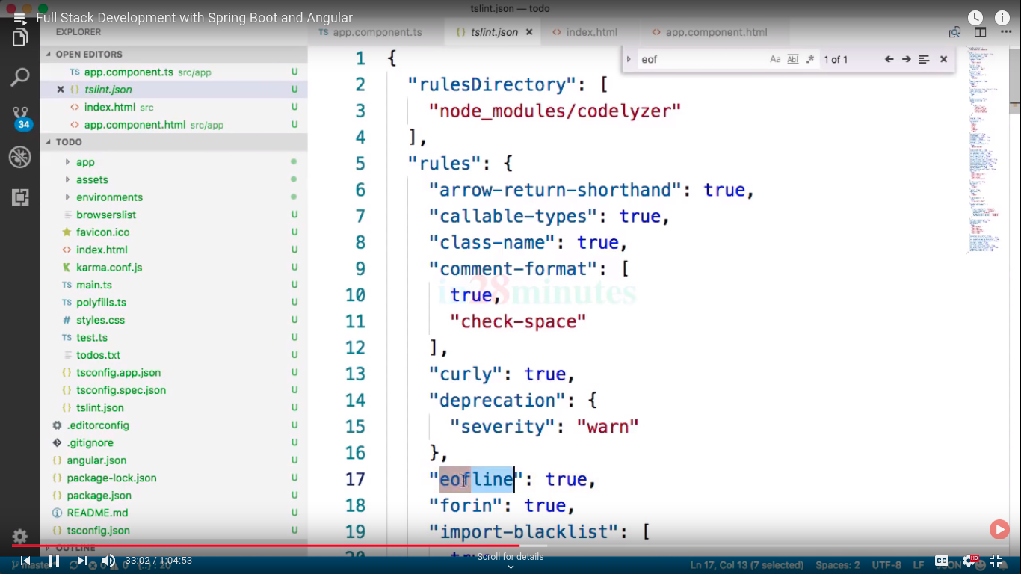

you can also customize this file..

ng build command:: ==> it create many files of bundle..

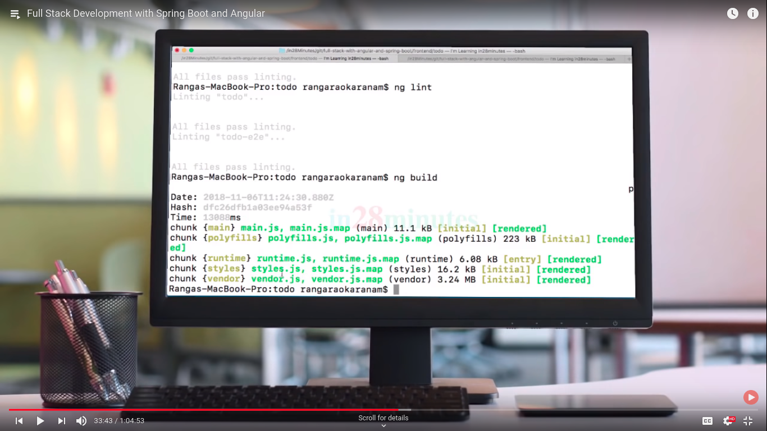

now in folder structure dist folder create now this folder is for build purpose and deploy your code in any server..

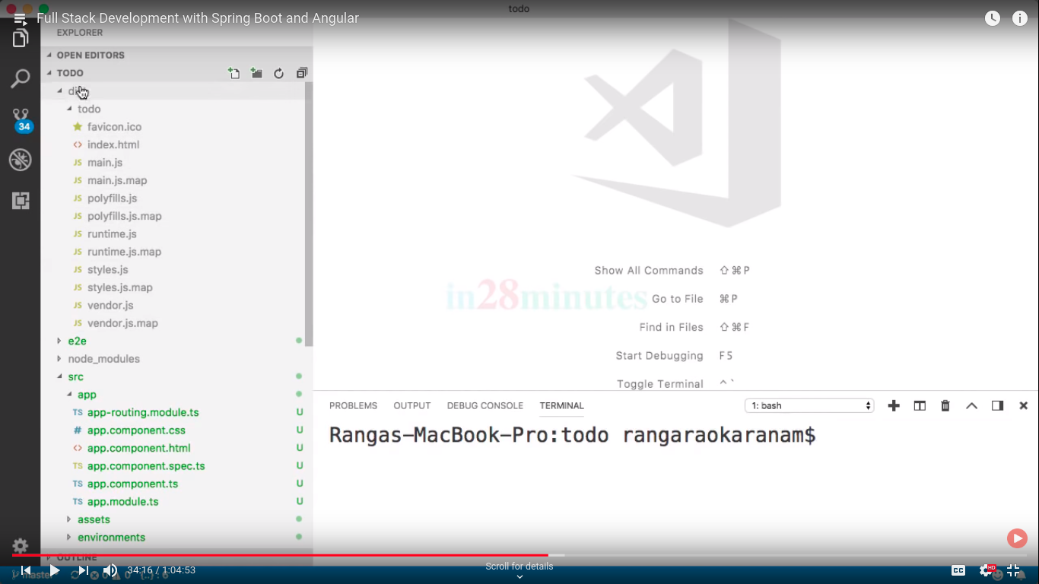

ng test for testing running unit test for that we are using jasmin framwork..

karma config file used for test case configuuration ..

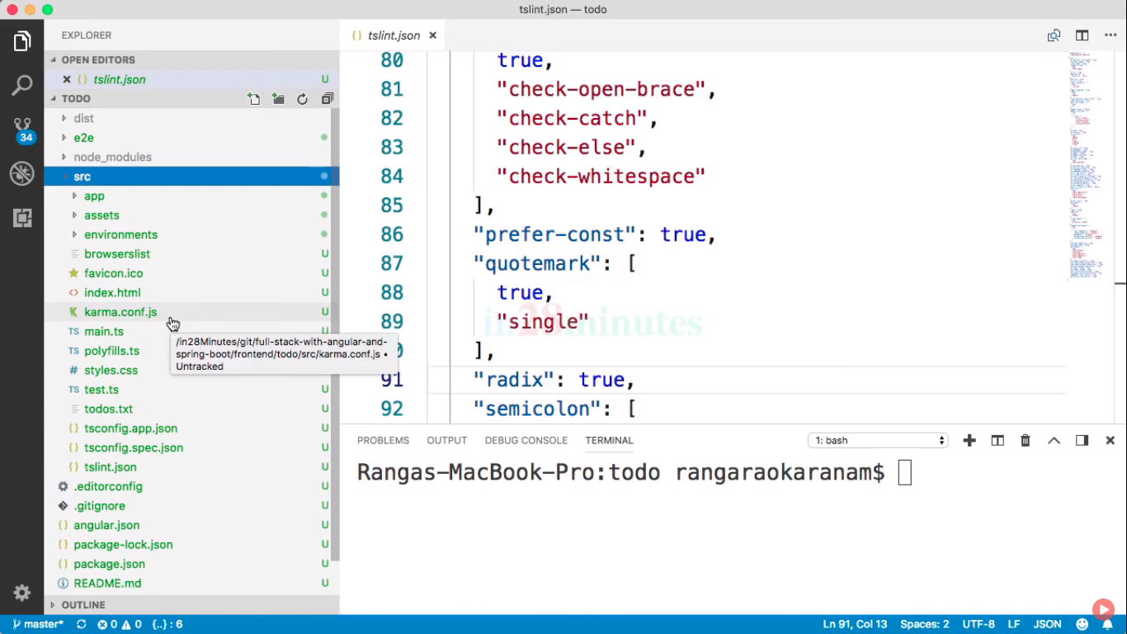

it is karma.config.js

app.component.spec.ts is for test cases file

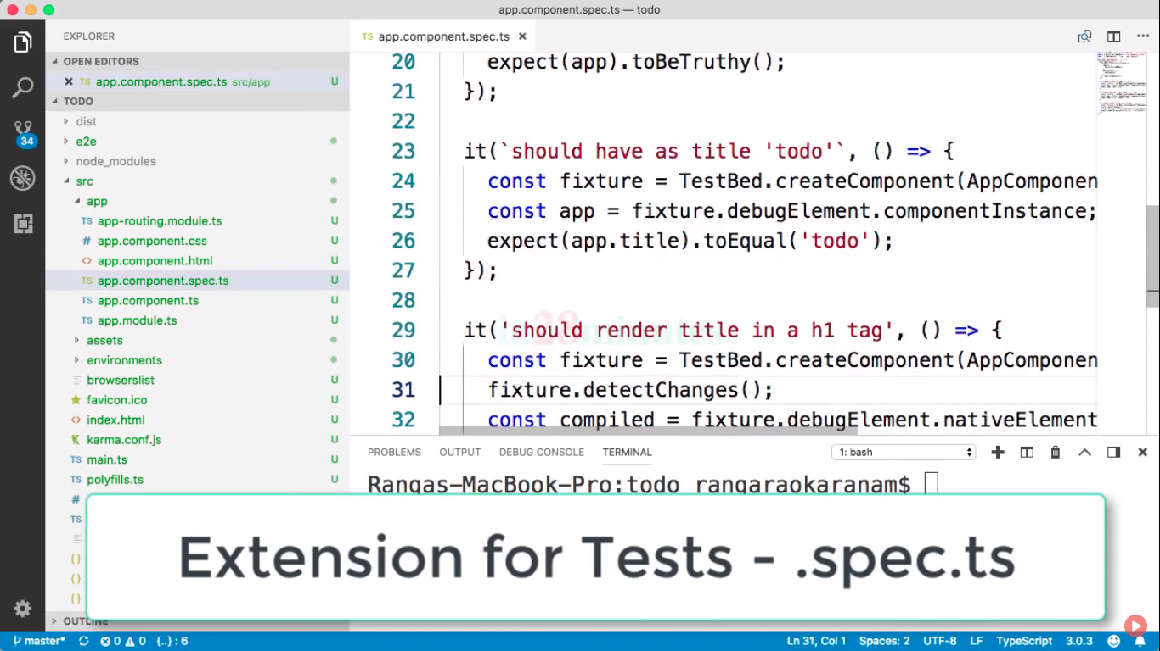

ng e2e ;; end to end test==>launch entire application..

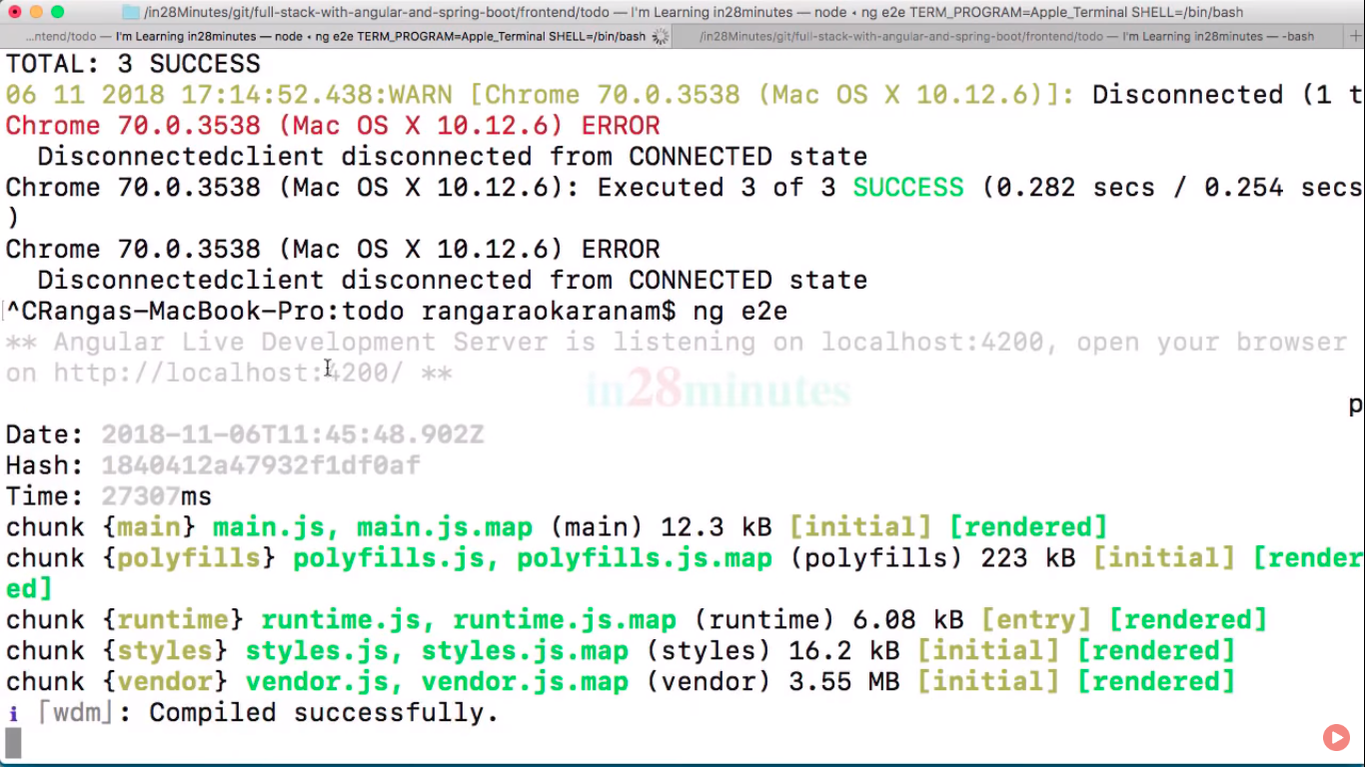

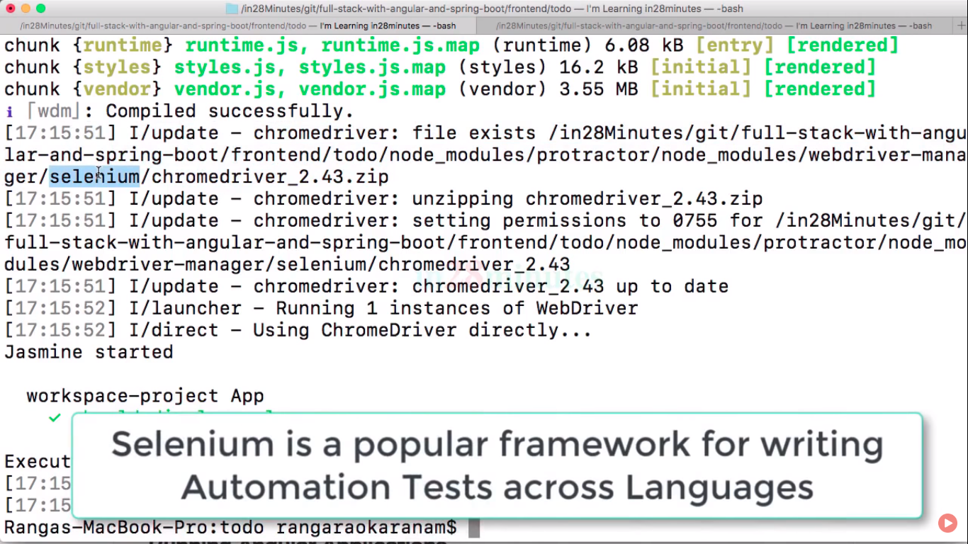

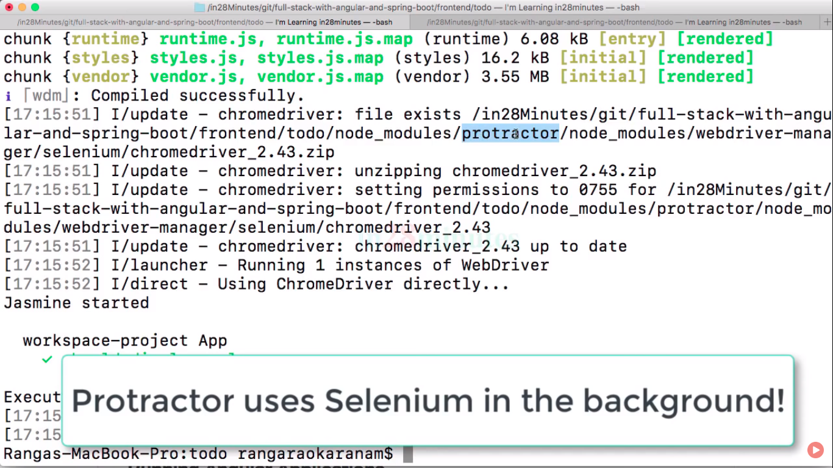

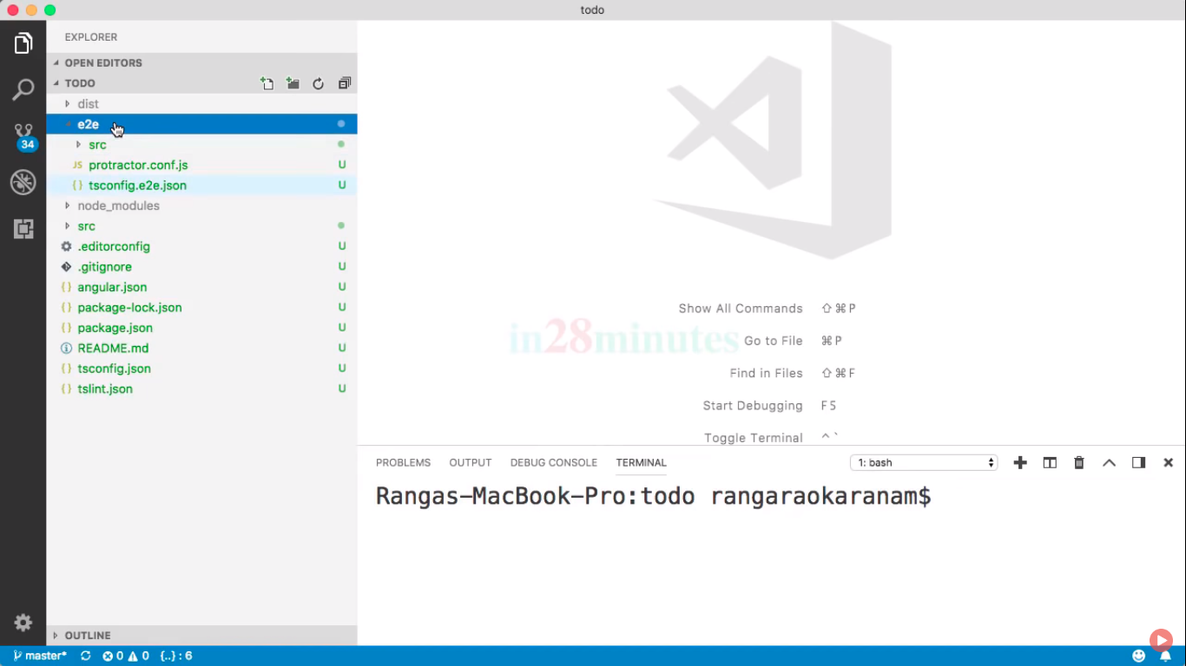

now angular.json usages for what happens when we run specific commands..

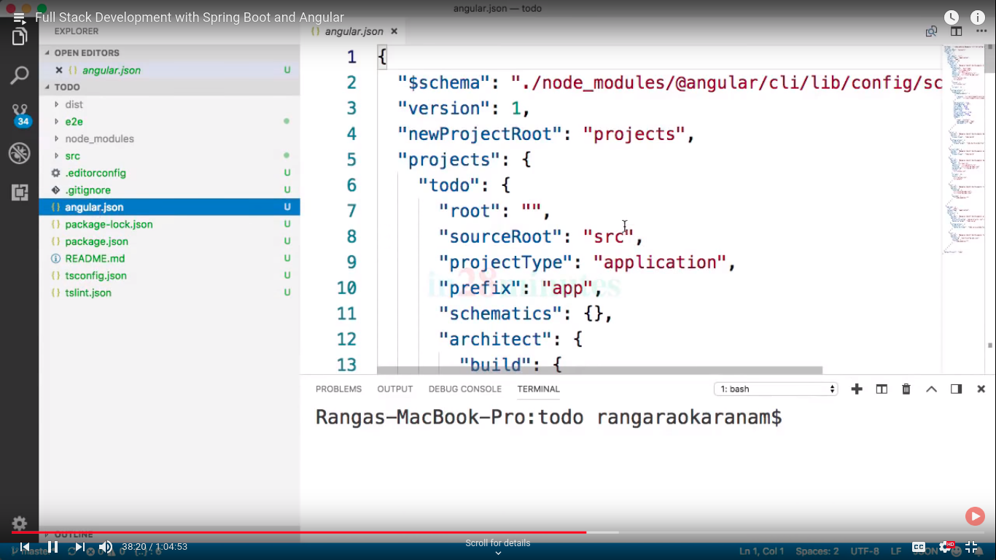

ng dist:: for deploy your app in another enviroment..

now going to another folder::  
app folder::

all codes or all angular code go into..

assets::

enviroment:: env. Present like qa production..

tsconfig.json::

your browser only know js then it specified by this file..

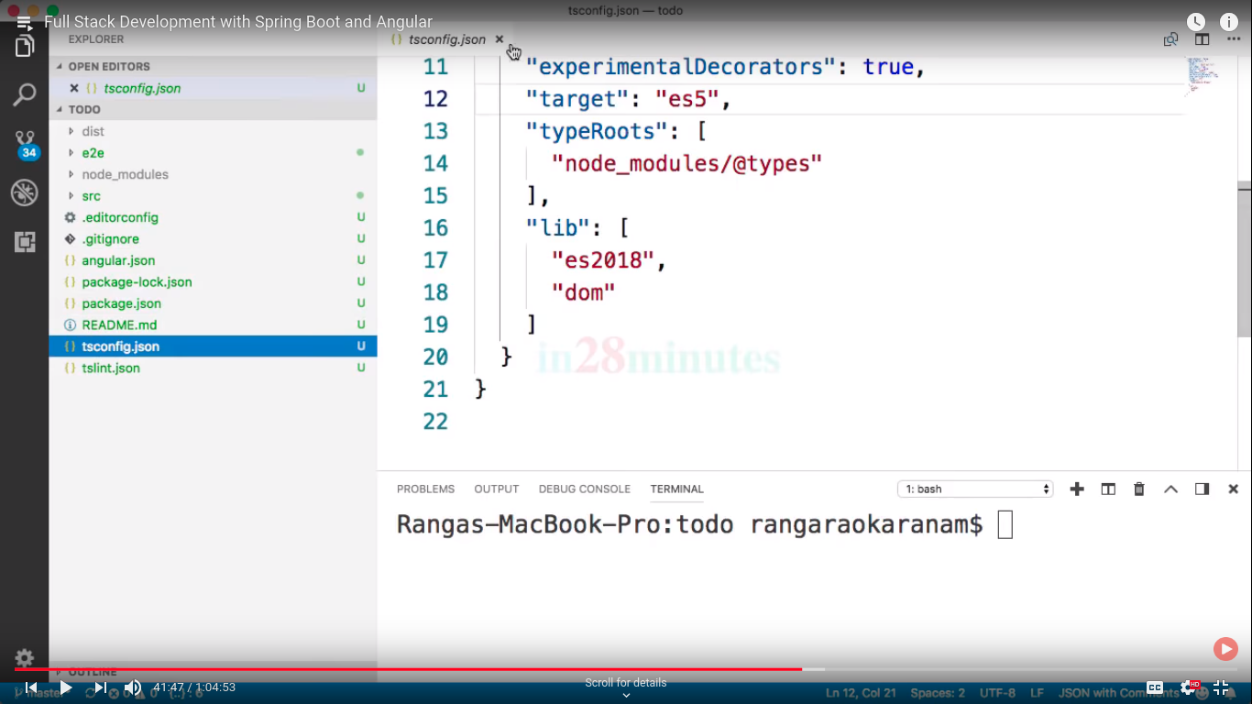

package.json::

all commands and framwork tools are on it..

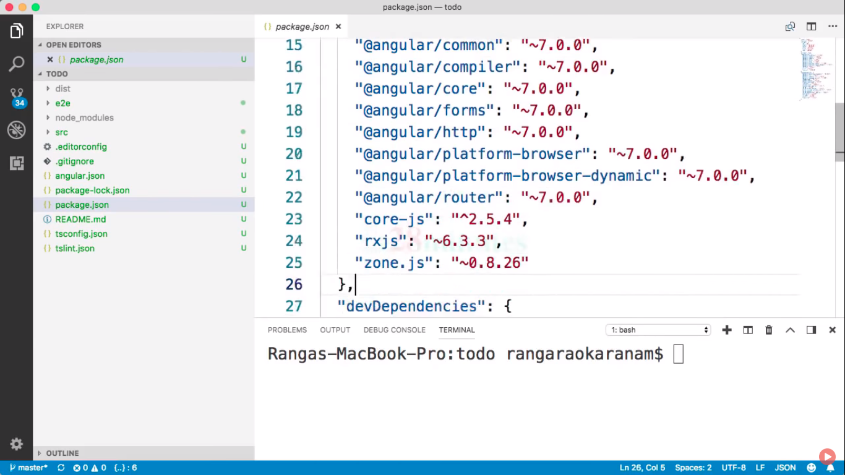

npm install command is used for downloading all dependecies present in package.json,and all are downloaded into ng_module..

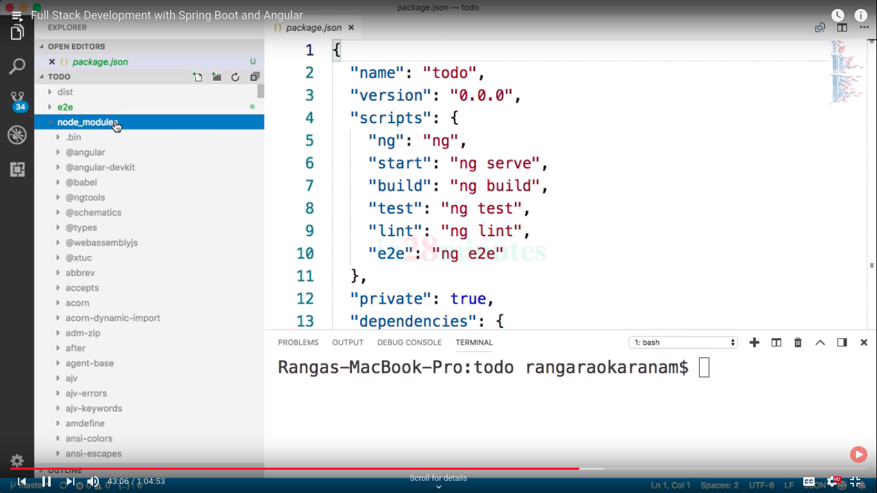

main.ts and index.html are loaded up when we load angular application..

polyfill.ts:: basically compatiblity checking among browsers.

Style.css :: global css.

Test.ts :: running all tests.

Now moves towards angular comonents::

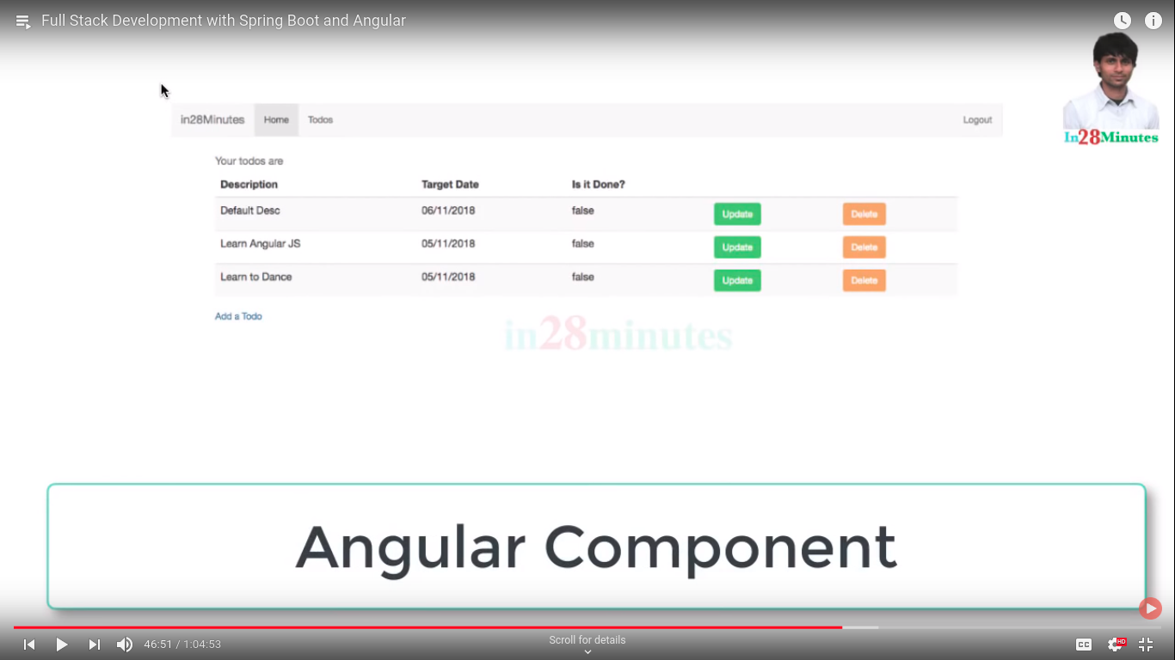

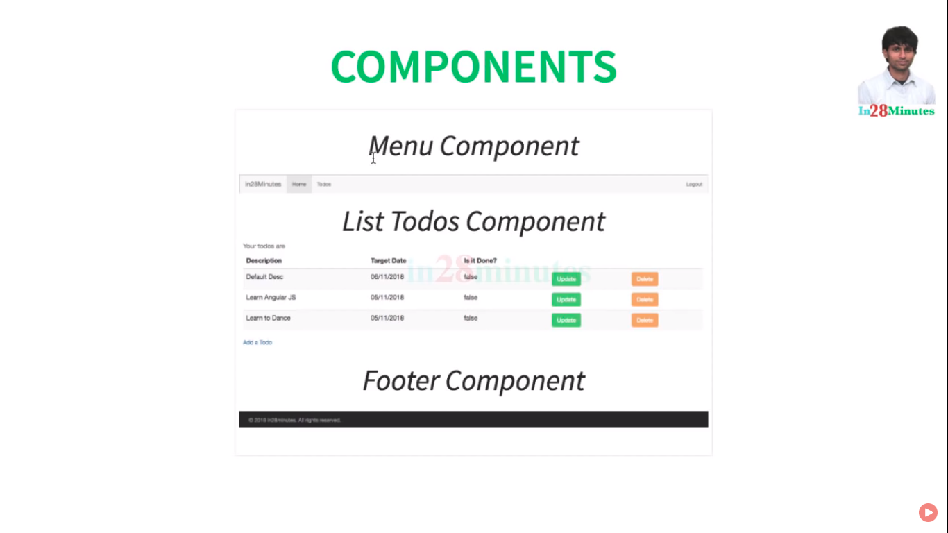

now components is associated with below diagrams::

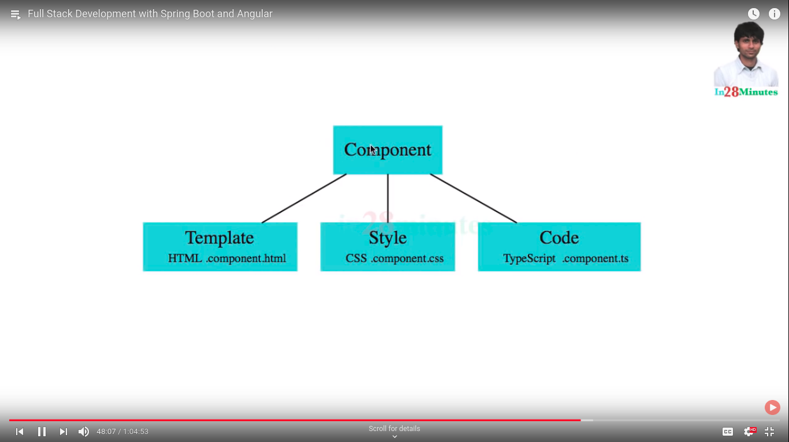

now in components we are using annoation or decorator for this..

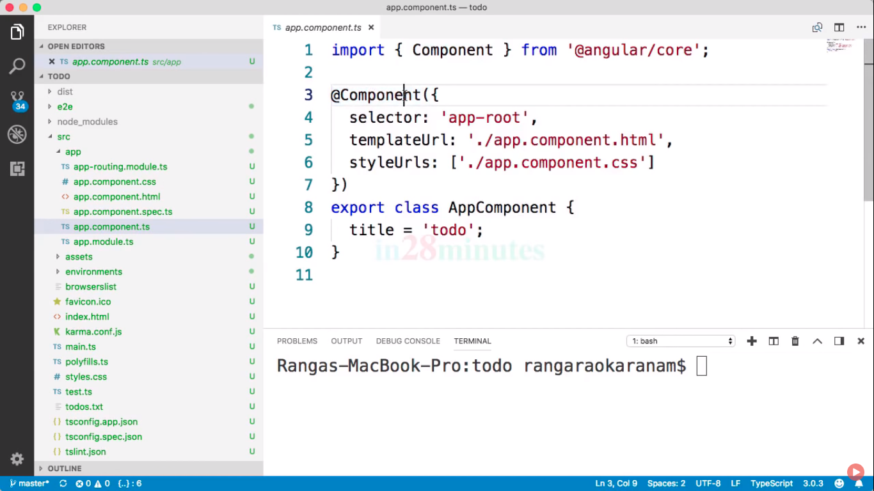

selector:: tag name.. like <app-root>

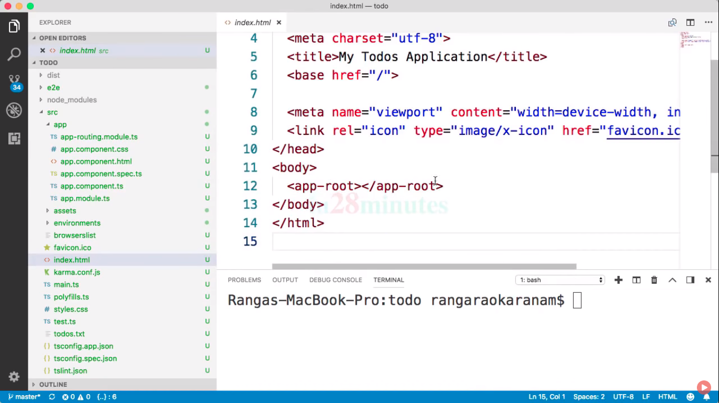

templet url::app.component.html.

SyleUrls:: css

now comes to coding where title mentioned ..

title=todo its member veriable

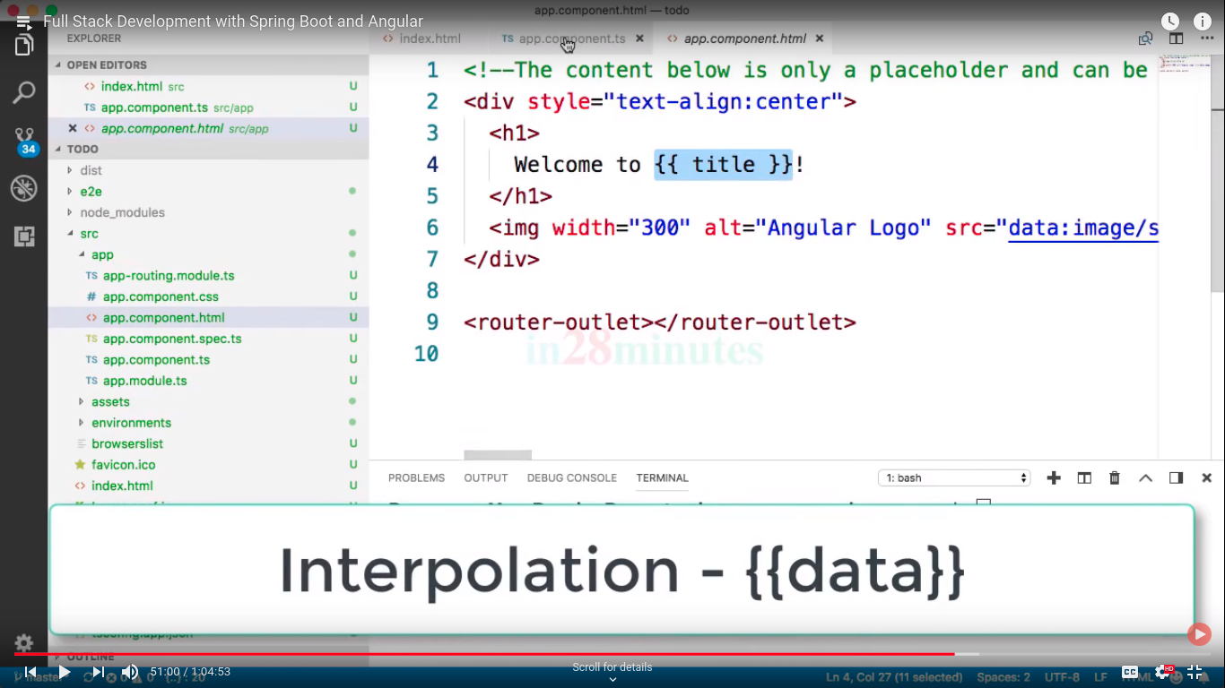

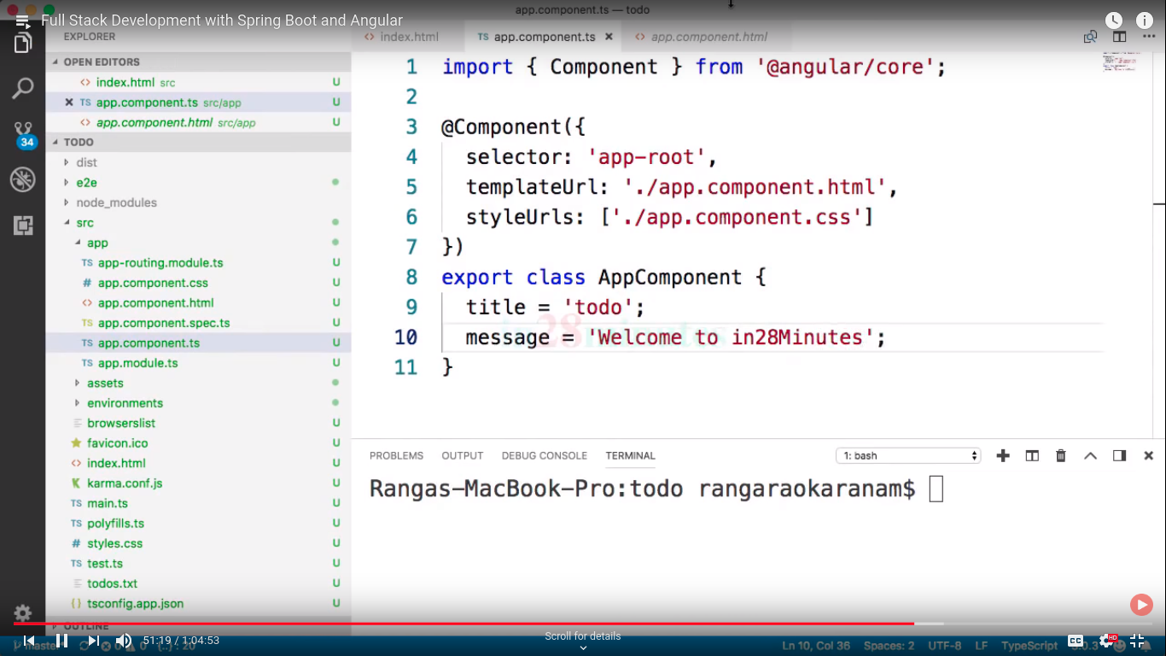



thats called databinding::

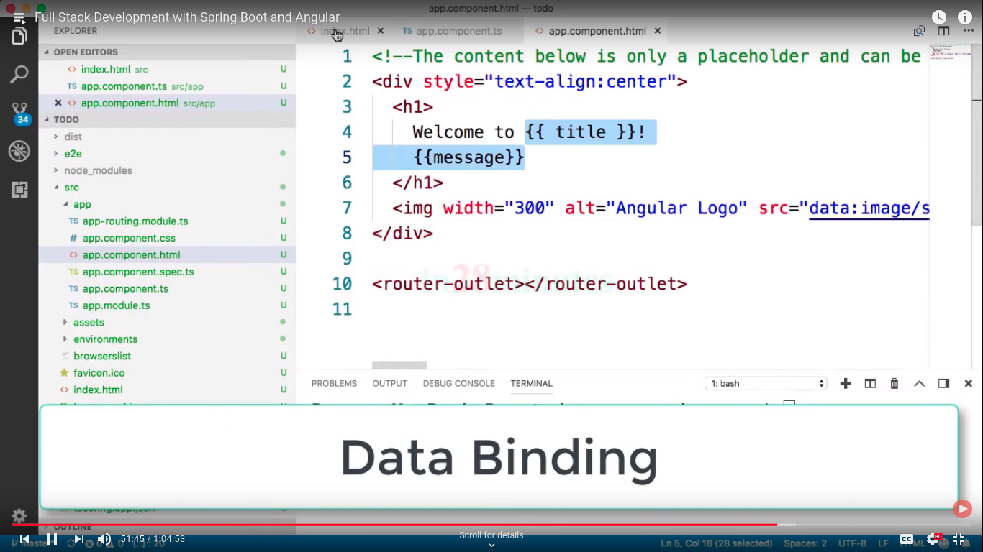

we can also directly define templete here::

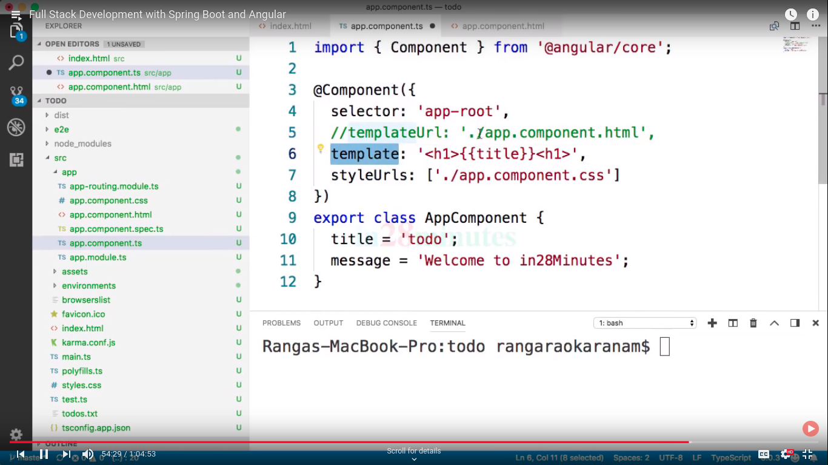now creating more components::

for creating module,service and componets running another cmd prompts..

ng generate component

for short cut you can also used ng g c

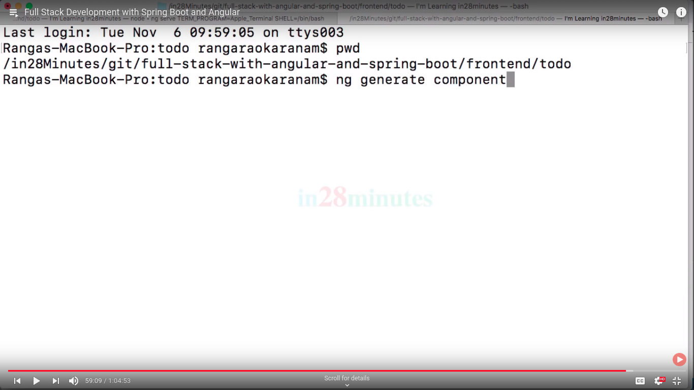

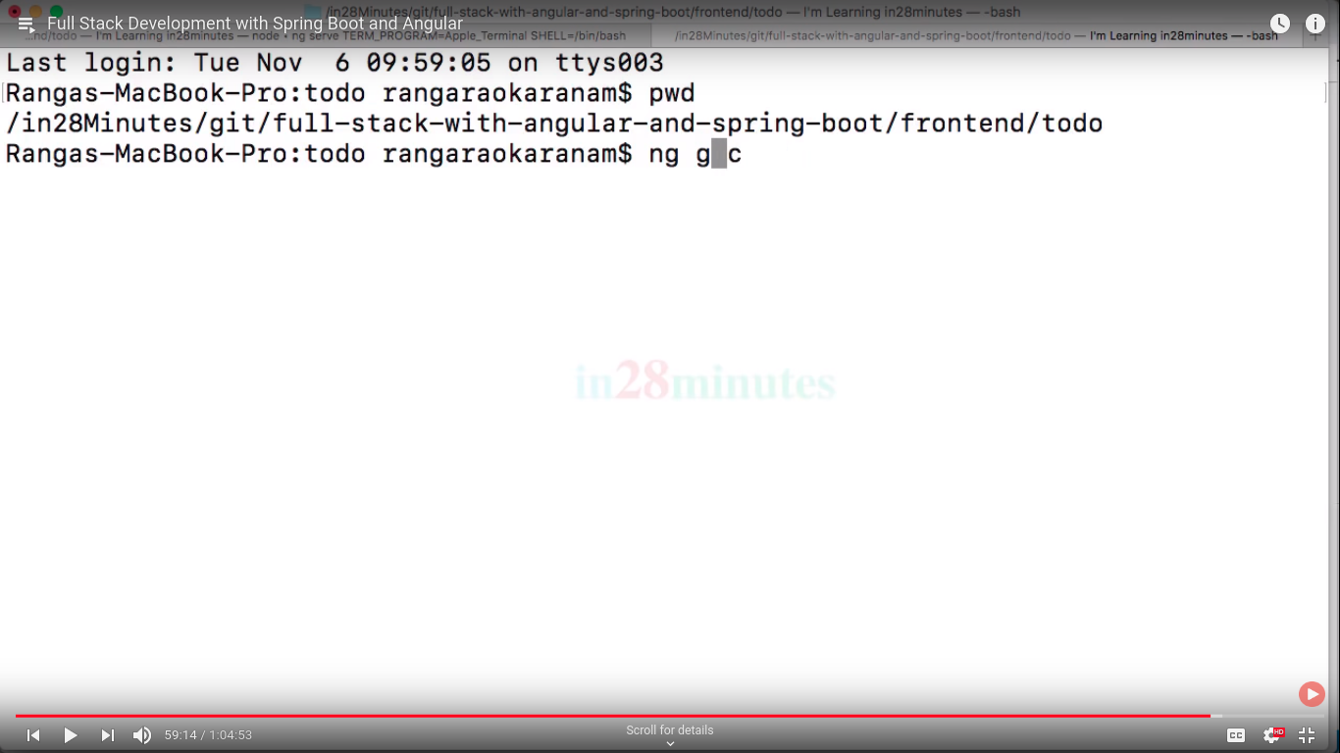

for genrating welcome componet bcoz it is not roll back

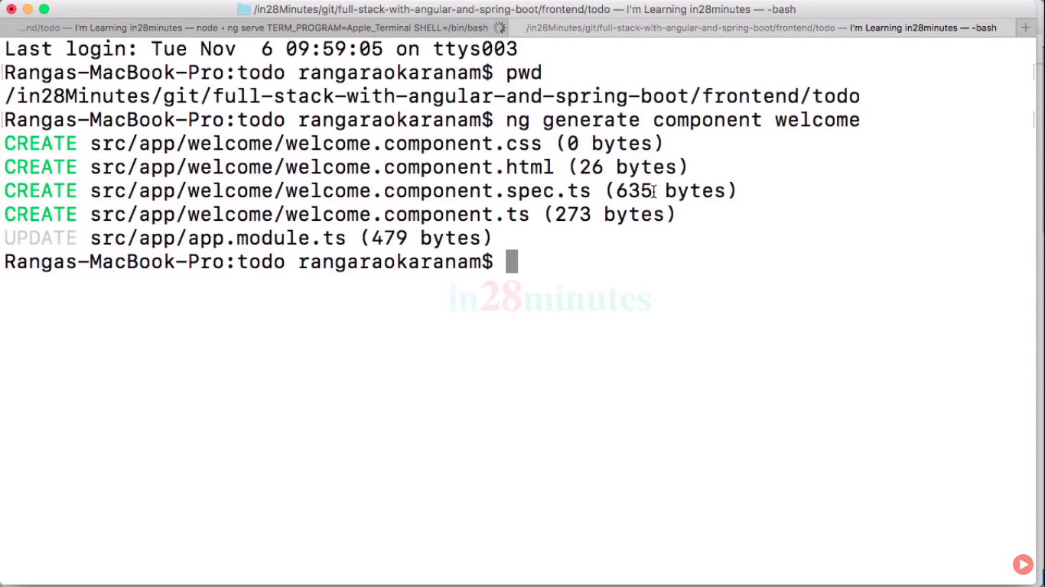

now app.module.ts also changed.

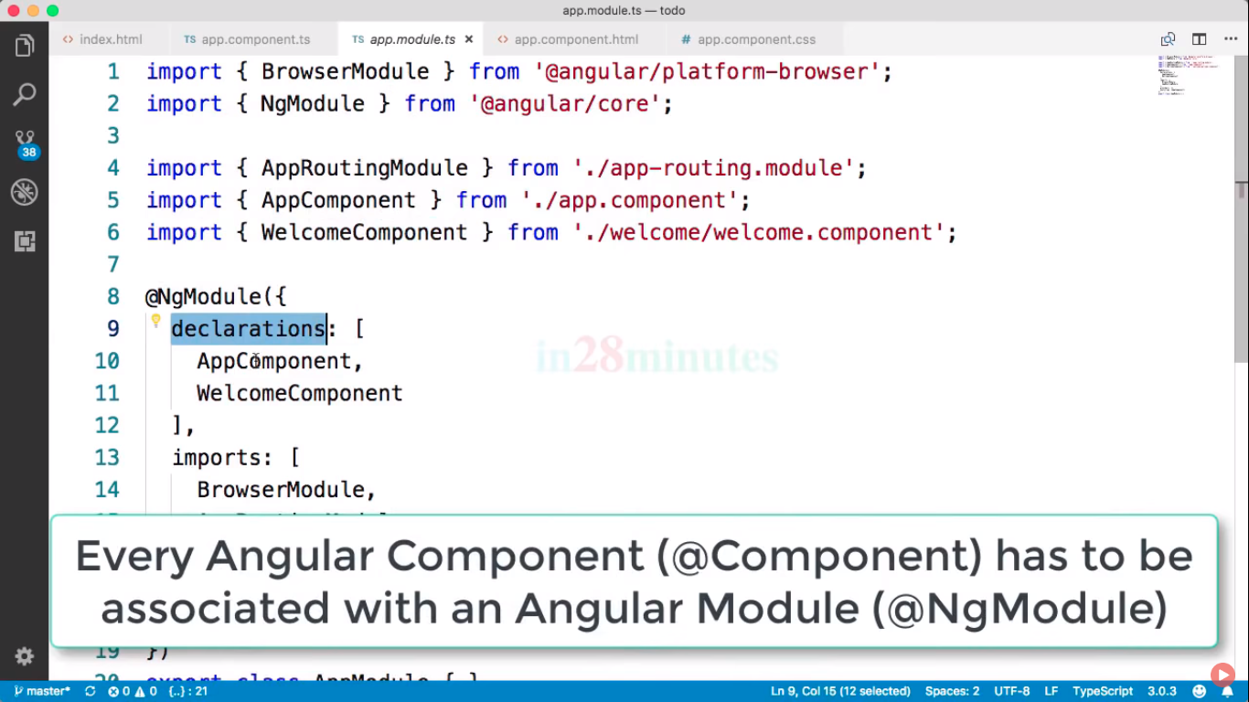

Always specified component in lower case..

use on OnInit::

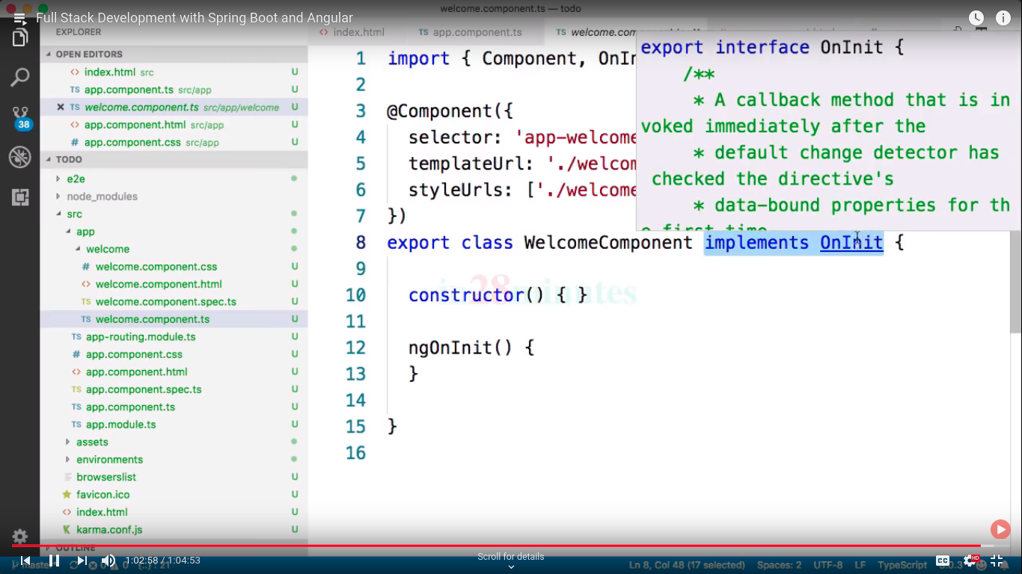

its interface on class